1. Introduction

This section of the report will explain how the shape and size of the vehicle has been decided as well as any developments that have led to making a decision on the final design for the outer frame. Aerodynamics and efficiency are the engineering principles used in the development of the shape/size of the *recumbent* vehicle.

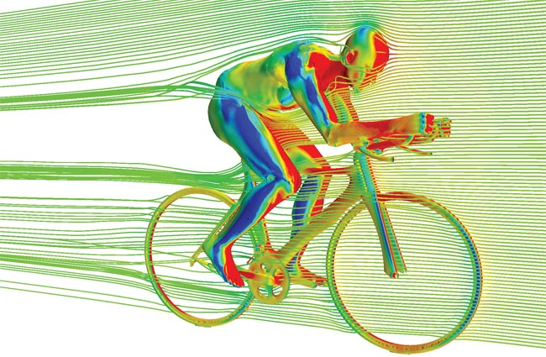

Figure 1[1]

1. Shape and Size

Shape and size entail the appearance, the outer frame and the dimensions of the vehicle. These aspects are very significant when designing the vehicle as the vehicle will need to be small enough for a single user to pedal/move while also allowing room for housing accessories, appliances and said user.

* 1. Appearance

The appearance of the vehicle will be modern and *streamlined* while maintaining an edge. Simple colors and lines will draw the user’s eye to the curves of the vehicle. Different coloured models are pictured below.

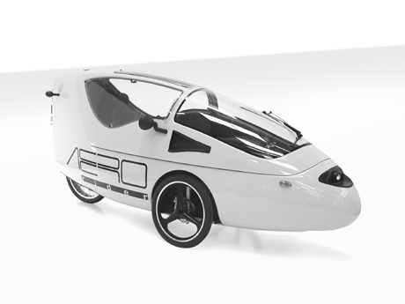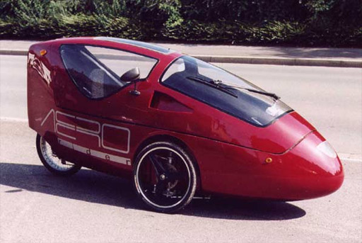  
 Figure 2[2] Figure 3[3]

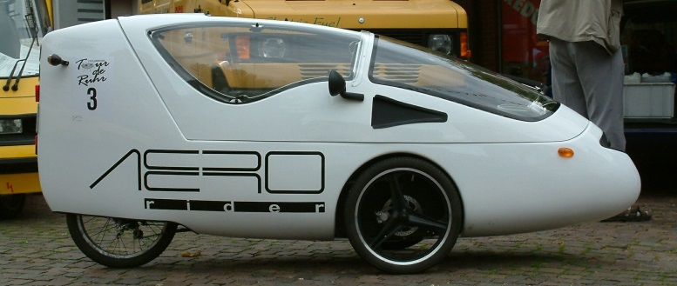  
 Figure 4[4]

* 1. Shape

The shape will also consider the winter season - and will minimize the snow collection on the roof. Aerodynamics will be carefully considered; making sure the bicycle weight will be *efficient* for the seasons and tasks provided. The model will be shaped similar to that of a raindrop, this will minimize air resistance, drag force, thereby reducing the total effort required to move the vehicle. To reduce the amount of snowfall collecting on the roof of the vehicle a sloped roof will be considered, by doing so, the user does not transport as much excess weight (snow) while peddling.

* 1. Dimensions

The dimensions of the tricycle have been specifically tailored to the size of Canadian bike lanes, enough space has been provided to comfortably fit the user as well as incorporate additional safety features. Dimensions are 2.78m long by 0.85m wide by 1.20m high. Each portion of the shell will be carefully considered as no space can be squandered.

To calculate the cost of materials, surface area will need to be calculated. The estimated surface area of the material required is roughly…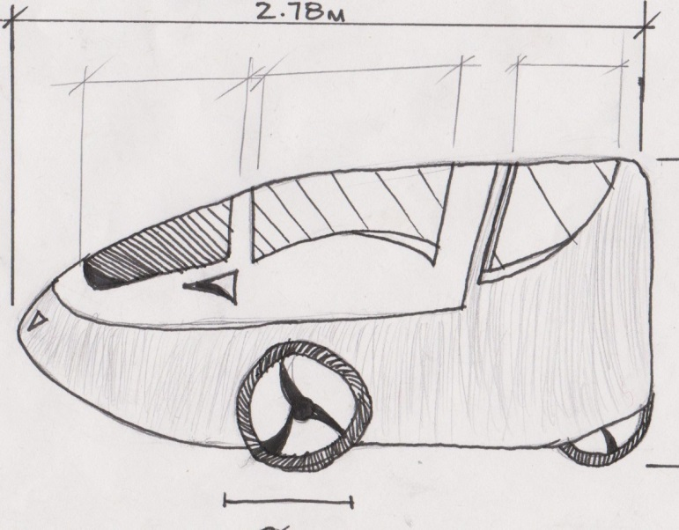  
 Figure 5 Figure 6

Second and third sketches will be inserted here

3. Glossary

Recumbent: Lying down, especially in a position of comfort or rest; reclining.

Streamlined: Design or provide with a form that presents very little resistance to a flow of air or water, increasing speed and ease of movement.

Aerodynamics: The properties of moving air, and esp. of the interaction between the air and solid bodies moving through it

Efficiency: Achieving maximum productivity with minimum wasted effort or expense.

References

1. James Thomas. (July 29, 2013). *Cycling 360 media* by *Victor Jimenez* [Online]. Available: <http://www.cycling360media.com/wp-content/uploads/2012/10/Adams_STAR-CCM1_650.jpg>
2. *Matt Kelly*. (July 16, 2009*) Aerorider: The ultimate single-seat hybrid* by *Matt Kelly*[Online] Available.   
   <http://www.examiner.com/article/aerorider-the-ultimate-single-seat-hybrid>

# 3. Jeroen Haringman (August 2,2007) Test drive Aerorider[Online]

<http://www.solarwebsite.nl/en/2007/08/proefrit-aerorider/>

## 4. Unknown.(December 22, 2010) [Handbuch für Elektrofahrräder & Pedelecs](http://www.nielsfries.de/literatur/pedelec/handbuch-fur-elektrofahrrader-pedelecs/)[Online]

<http://www.nielsfries.de/literatur/pedelec/handbuch-fur-elektrofahrrader-pedelecs/>